Country: | My House Plan |  | Name:
Where it is in the world.  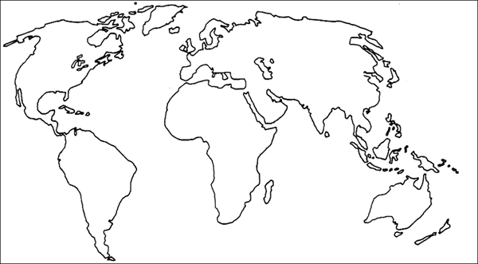 |  | What the weather is like. | What the landscape is like.
 |  |  | What the economy is like.
What kind of houses they have there. |  | What kind of materials they build their houses from. | Why they build their houses from these materials.
Would you like to live in that kind of house?

Photos from this country
A map | A house | The landscape
People | Weather | Clothing

